**Lab 1 Design Record**

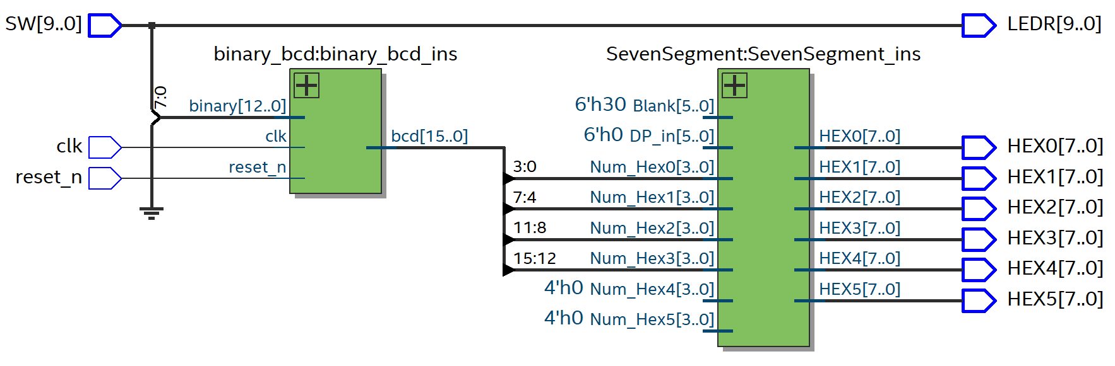**Students: Denis Onen, Svetlana Yanushkevich, Norm Bartley**

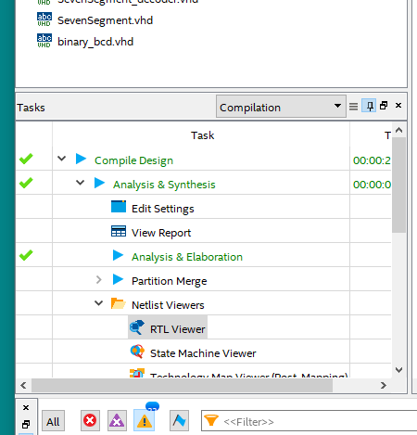**Tasks**: Compile Design > Analysis & Synthesis > Netlist Viewers > RTL Viewer

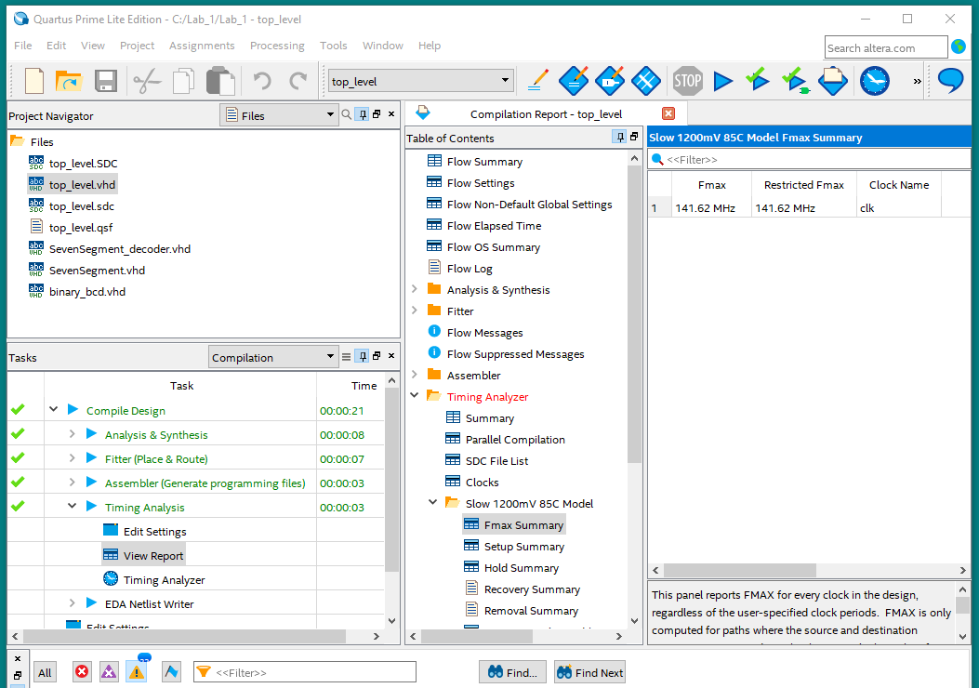

**Tasks**: Compile Design > Timing Analysis > View Report

**Table of Contents**: Timing Analyzer > Slow 1200mV 85C Model > Fmax Summary

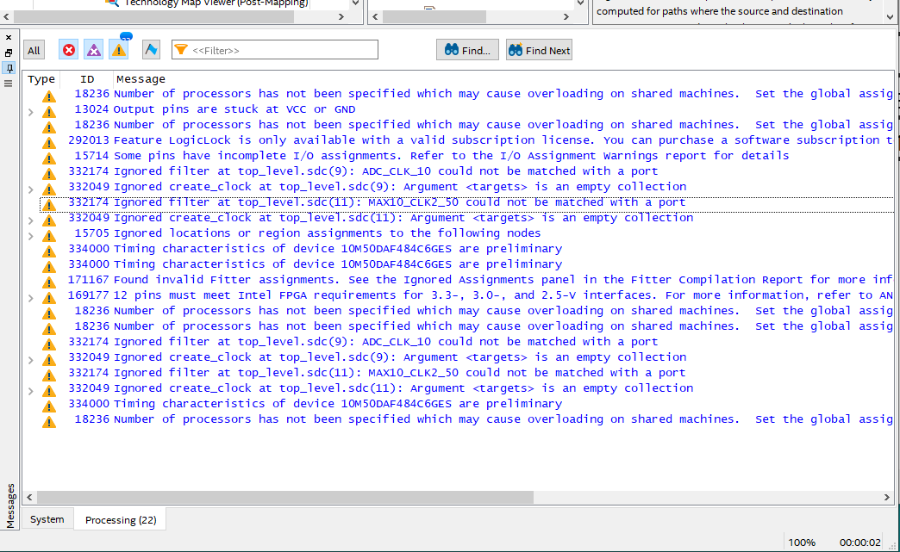

Show the Messages window and click: **Show Error Messages** (red circle with white x); **Show Critical Warning Messages** (purple triangle with white x), and **Show Warning Messages** (yellow triangle with black exclamation mark). Basically, we don’t want to see the green messages. Show all the messages required and use multiple screenshots if you have multiple pages of the required messages.

Place your ModelSim simulation waveform(s) on this page, with descriptive titles.

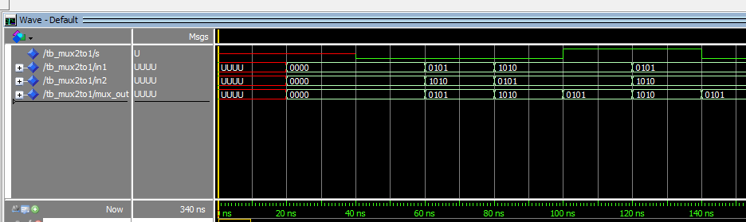**MUX2TO1 simulation**

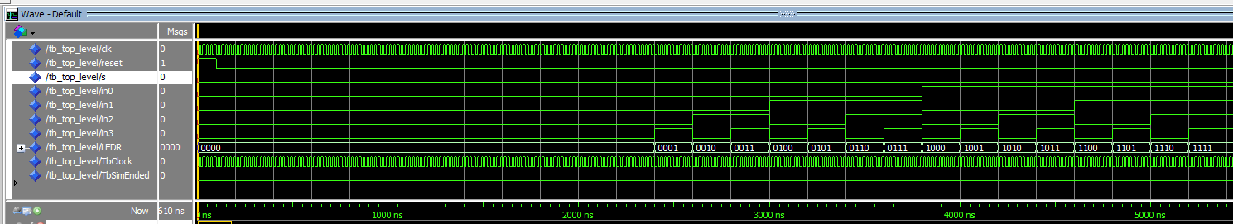**top_level simulation**